

Kingdom of Saudi Arabia

Ministry of Education

Imam Abdulrahman bin Faisal University

Computer Science department

College of Science and Humanities

**CIS211– Web based systems**

**Term 3– 2022/2023**

Web Based Systems Projects

For

[Ateyq Website]



**CS Year 4, G5**

**[Ms.** **Raja Alyaffer]**

[Team Members]

|  |  |  |
| --- | --- | --- |
| **#** | **Name** | **ID** |
| **1** | **Shahad Emad Aljian** | **2200003861** |
| **2** | **Amal mohammed Alotaibi** | **2200001746** |
| **3** | **Renad abdulaziz alshahrani** | **2200002949** |
| **4** | **Layan saleh Alghamdi** | **2200002543** |
| **4** | **Ghaidaa Alotaibi** | **2200002446** |

Table of contents

Contents

1. Introduction 5

2. Ateyq interfaces 5

2.1 Ateyq Homepage interface 5

2.3 SIGN IN interface 7

2.4 SIGN UP Interface 8

2.5 USERPFROFILE Interface 8

3. Products 9

3.1 TEA interface 9

3.2 CUPS Interface 9

3.3 MAGAZAINES Interface 10

3.4 HANDMADE Interface 10

4. Contact Us Interface 11

5. Checkout interface 14

5.1 Shopping cart 14

5.2 Payment Details 14

5.3 Done 15

6. Database of ateyq 16

6.1 Product table: 16

6.2 Pay table: 17

6.3 Contact us table: 17

6.4 Cart_data table: 18

7. Tables 18

7.1 Cart Table 18

Table 1: Cart Table 18

7.2 Products Table 18

Table 3: Product Table 18

7.3 Sign in Table 19

Table 3: Sign in Table 19

7.4 Sign up Table 19

Table 4: Sign up Table 19

7.5 user Table 19

Table 5: User Table 19

8. ER Design 20

9. Fulfilled Requirements 21

10. Testing Case 22

11. Conclusion 24

Table of Figures

Figure 1Ateyq Homepage interface 5

Figure 2 About Us interface 6

Figure 3 6

Figure 4 7

Figure 5 SIGN IN interface 7

Figure 6 SIGN UP Interface 8

Figure 7 USERPROFILE Interface 8

Figure 8 TEA interface 9

Figure 9 CUPS Interface 9

Figure 10 MAGAZAINES Interface 10

Figure 11 HANDMADE Interface 10

Figure 12 Contact Us Interface 11

Figure 13 11

Figure 14 12

Figure 15 12

Figure 16 13

Figure 17 Shopping cart 14

Figure 18 Payment Details 14

Figure 19 Done 15

Figure 20 Ateyq database 16

Figure 21 Proudct table 16

Figure 22 Pay table 17

Figure 23 Contact us table 17

Figure 24 Cart_data table 18

Figure 25 ER Design 20

Figure 26 22

Figure 27 22

Figure 28 23

Figure 29 23

# 1. Introduction

This project aims on designing and developing a website using HTML, CSS, PHP and JavaScript for a local store called “Ateyq”, which is a store that sells elegant products such as handmade cups and plates as well ass vintage products. The developed website will provide customers with flexibility during the processes of viewing the product and past purchase. Also, the developed website will allow customers to send their feedback or any concerns by using the designed contact page.

# 2. Ateyq interfaces

The purpose of this section is to list all the pages of the Atiq website along with their functions

## 2.1 Ateyq Homepage interface

In the main page of the Ateyq website, there is a content bar on the top right of the page that is classified according to the sections of the entire Atiq site, followed by all the products that the site is offering to its visitors in the center of the page, "cups, handmade, magazines and tea”.

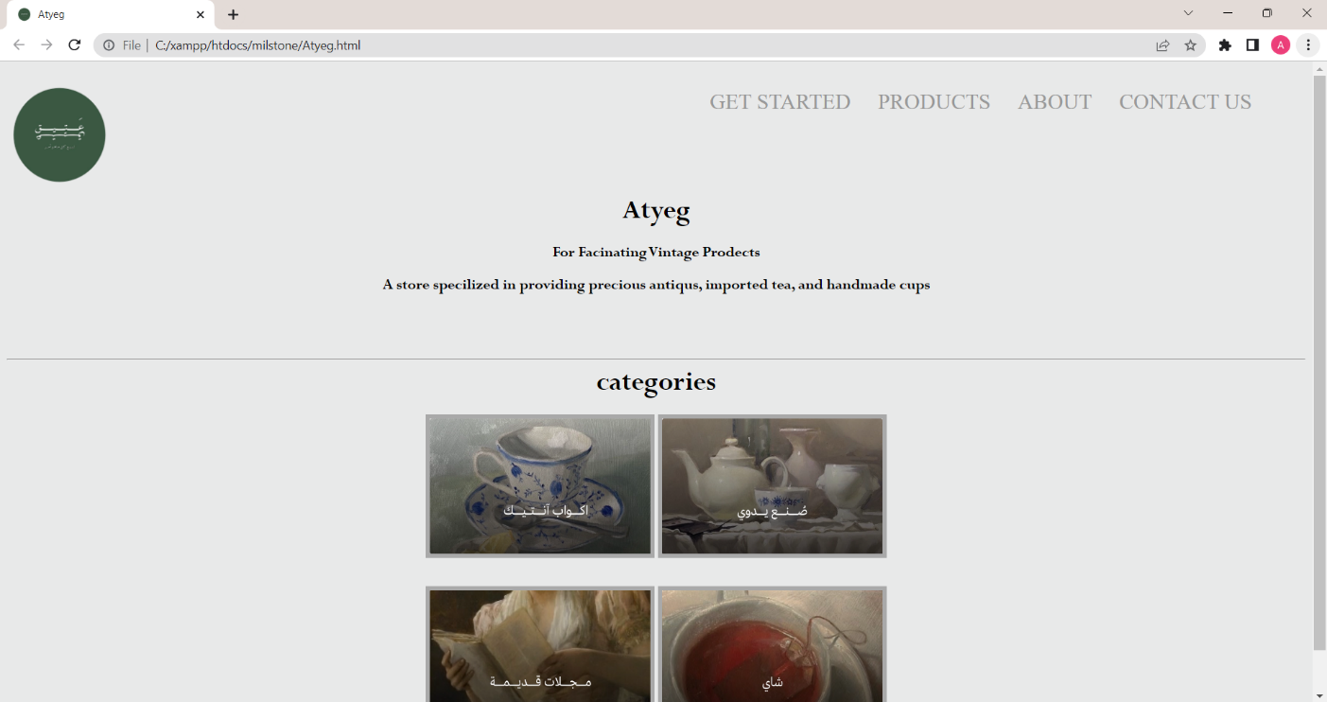

Figure 1Ateyq Homepage interface

2.2 About Us interface

In the About us page of there is a description of atyeq and explanation of antic, Also Exchange and return policy that user should know, in addition Intellectual property rights.

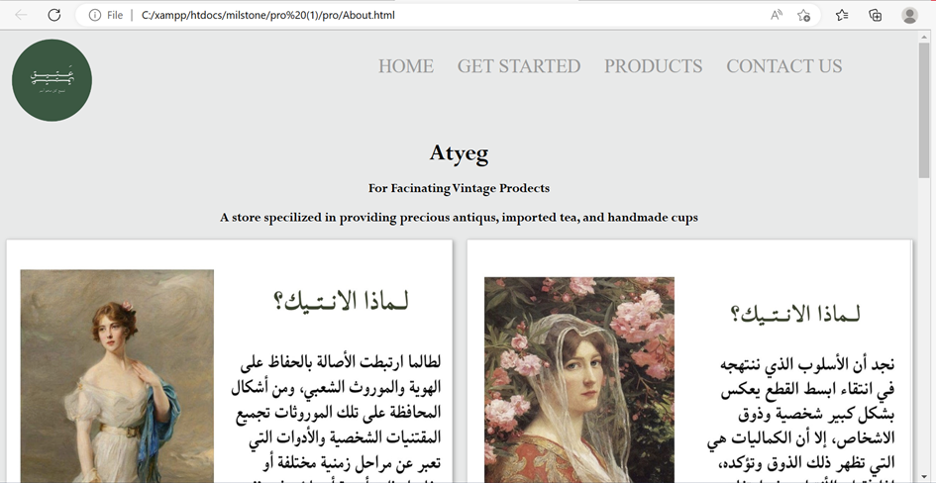

Figure 2 About Us interface

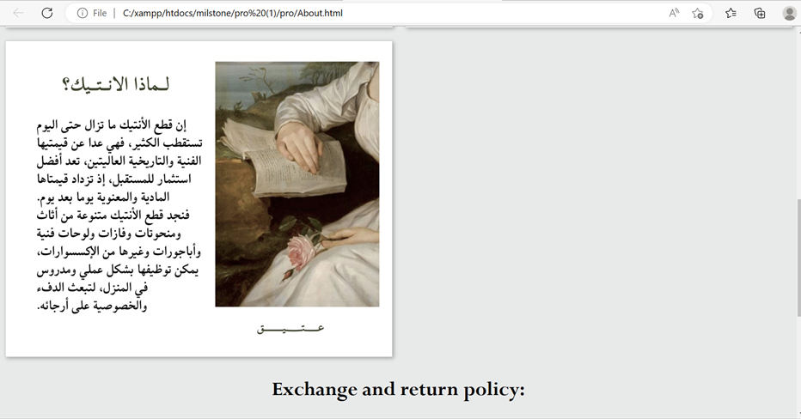

Figure 3

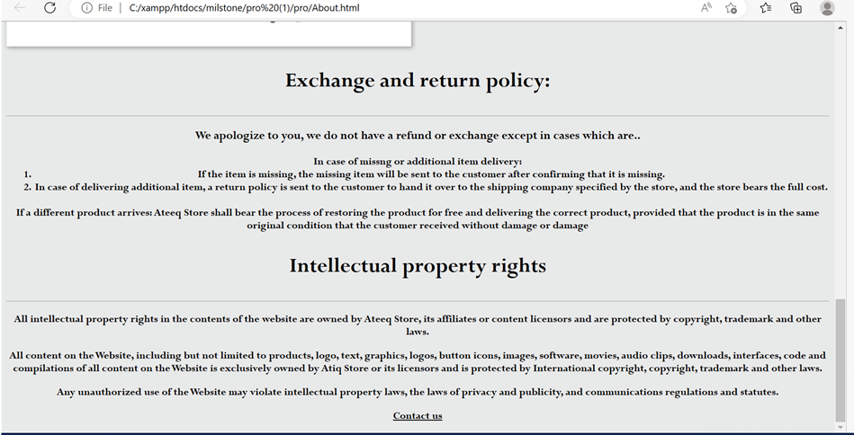

Figure 4

## 2.3 SIGN IN interface

It is imperative that the user logs in through the “sign in” page in order for him to be able to have a realistic shopping experience.

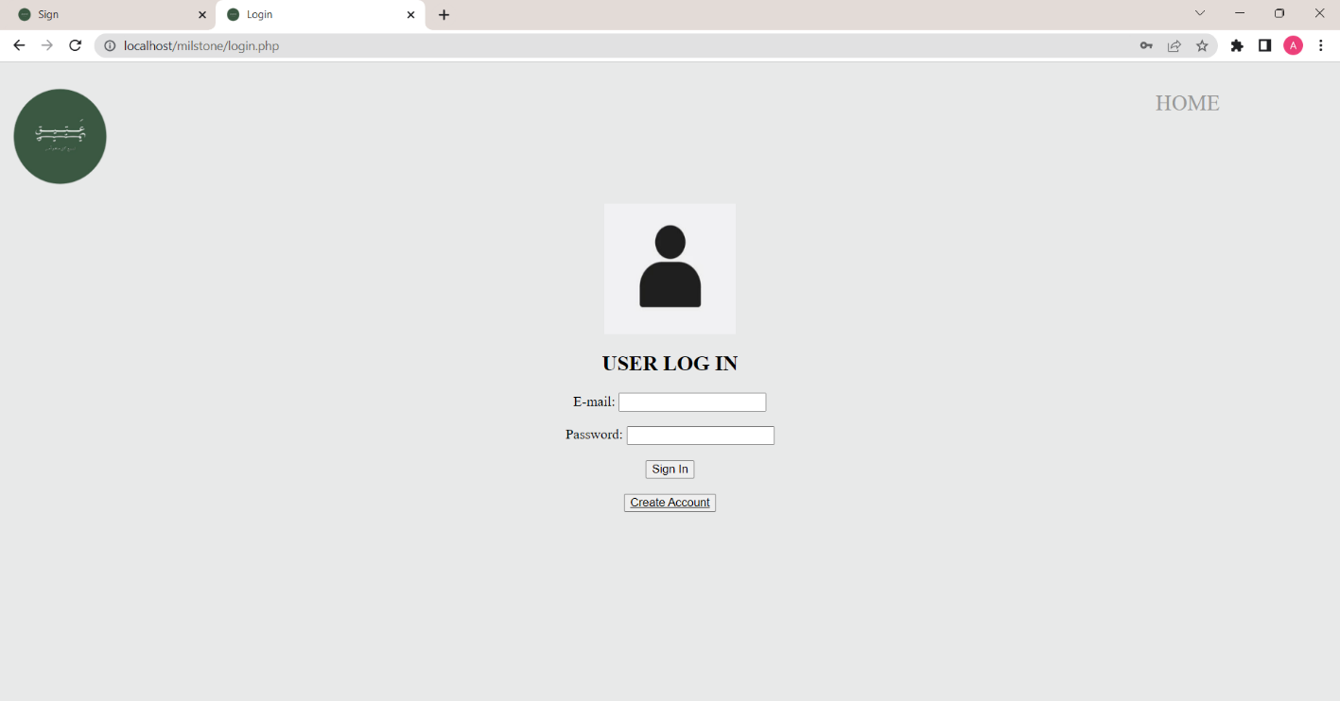

Figure SIGN IN interface

## 2.4 SIGN UP Interface

The user has the option to create an account if he or she does not have an account on the website. The information entered by the user will be stored in the database using PHPmyAdmin.

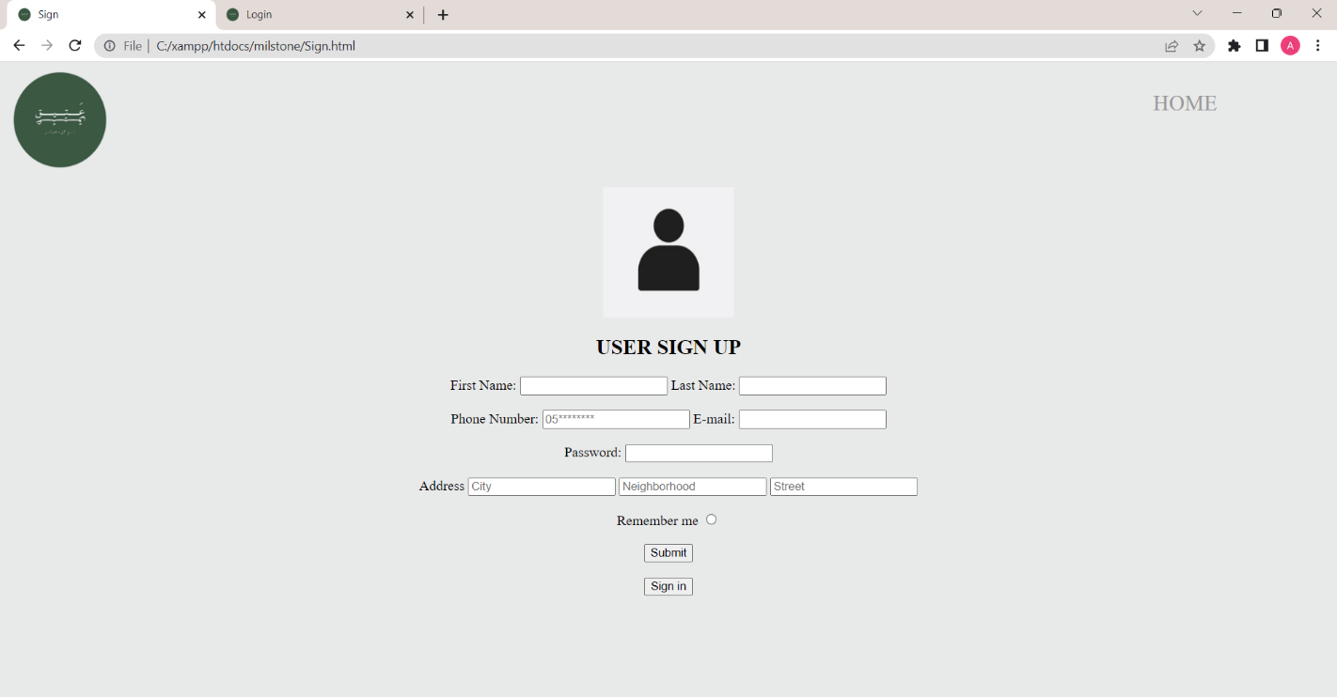

Figure SIGN UP Interface

## 2.5 USERPFROFILE Interface

A user's profile information will be saved using PHP after they log in to their account and sign up on the "UserProfile" page after entering the data.

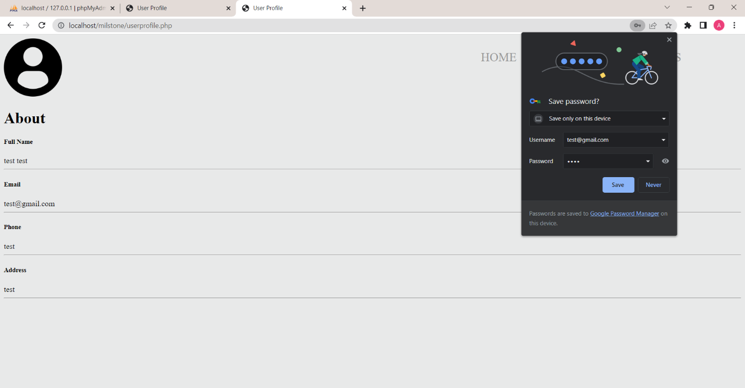

Figure USERPROFILE Interface

# 3. Products

Ateyq website offers four main categories of products, which are: tea, cups, magazines, and handmade items and there is also an "Add to Cart" button that, when the user selects a product, it will automatically be added to the cart.

## 3.1 TEA interface

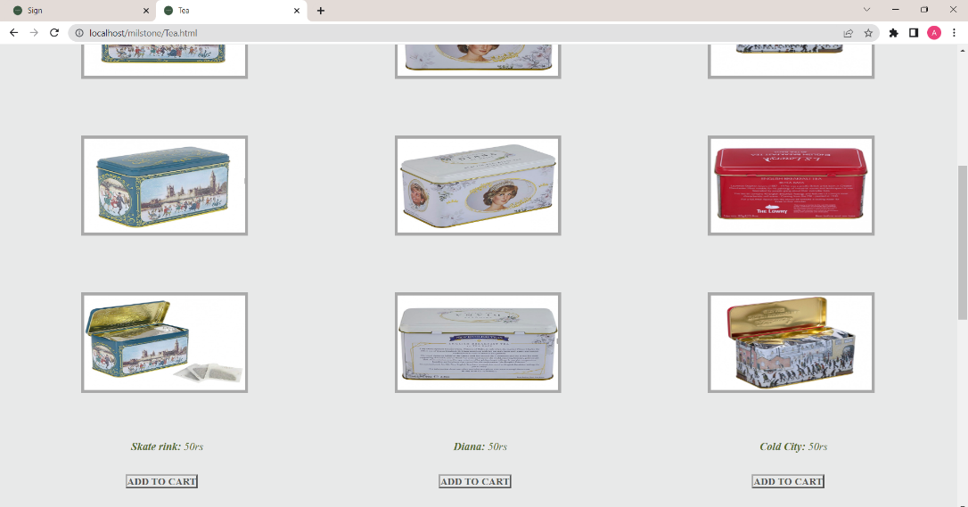

Figure TEA interface

## 3.2 CUPS Interface

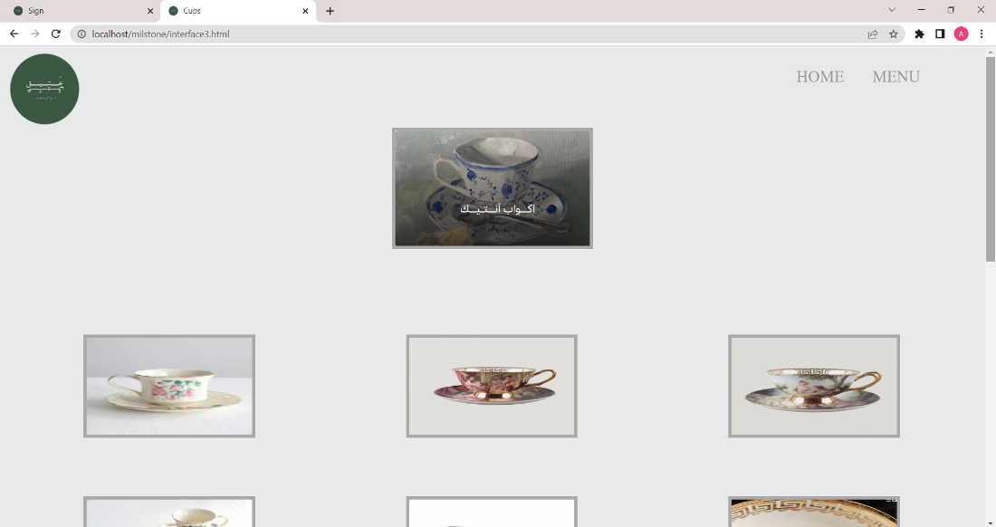

Figure CUPS Interface

## 3.3 MAGAZAINES Interface

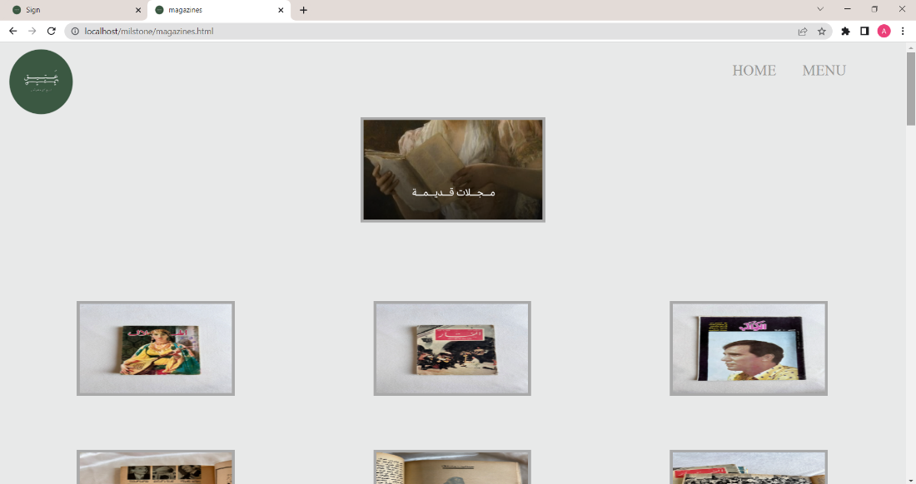

Figure MAGAZAINES Interface

## 3.4 HANDMADE Interface

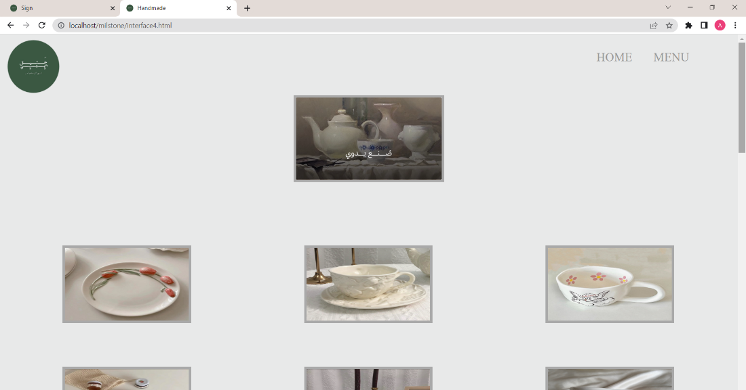

Figure HANDMADE Interface

# 4. Contact Us Interface

Ateyq website enable user to contact with the owner by contact page user will enter all information then there is text area he will write problem that he want to solve by owner . there is

"Submit" button that, when the user finish write his message, it will click on it then it will sends.

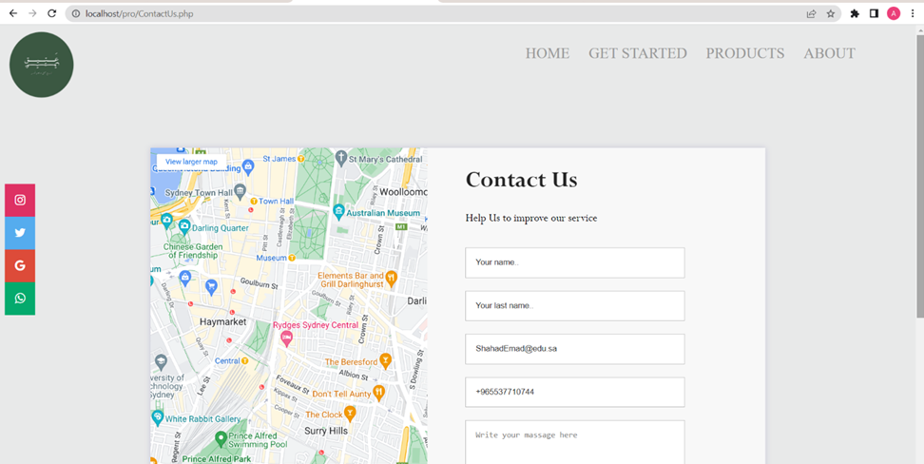

Figure Contact Us Interface

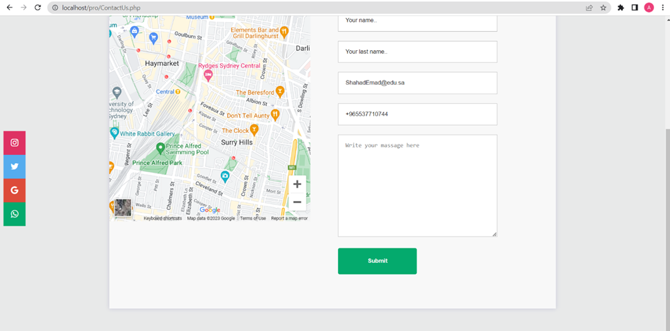

Figure

If user fill the blank with correct information, it will show message that message was received figure below show the message

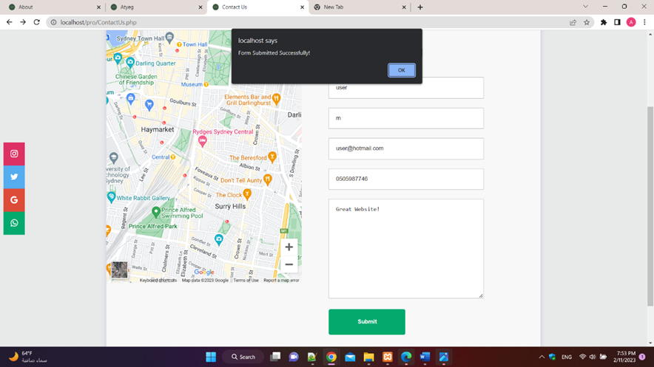

Figure

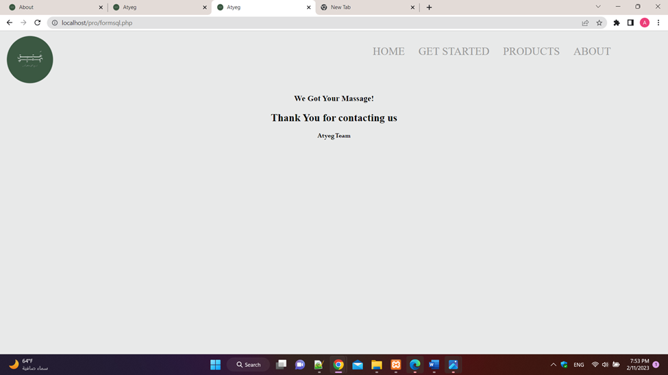

Figure

If user fill the blank with wrong information, it will show message figure below show the message

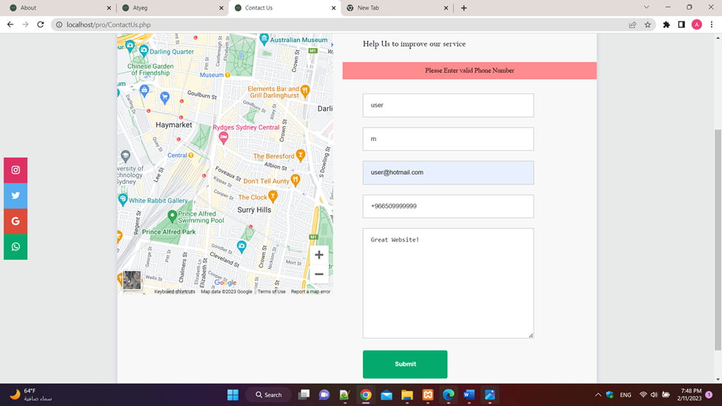

Figure

# 5. Checkout interface

## 5.1 Shopping cart

The activity selected by the user will appear on the shopping cart page, in addition to determining the quantity, the total will be calculated based on this quantity.

Figure Shopping cart

## 5.2 Payment Details

To complete the payment process and move to the next page, you must complete all the required information.

Figure Payment Details

## 5.3 Done

After completing the payment and confirmation, this page will appear and when you click on "Back to Home", it will move to the home page.

Figure Done

# 6. Database of ateyq

Ateyq database it contains 5 tables that store data that proccesd by Ateyq pages

User table : Stores information of user , id ( Primry key ), first name , last name , phone number , email , password , address , neighborhood, street , remember .

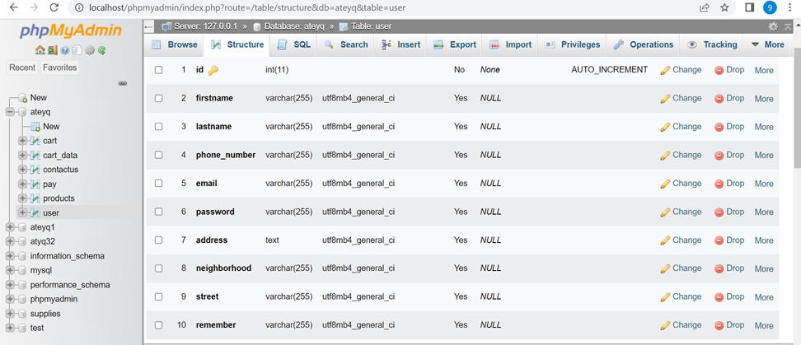

Figure Ateyq database

## 6.1 Product table:

Stores information about products price, cups, magazines, handmade , tea , price ( Primary key )

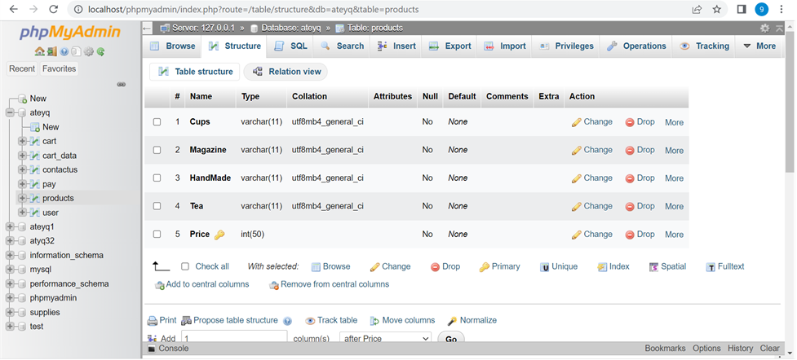

Figure Proudct table

## 6.2 Pay table:

Stores information about payment card number (Primary key) , card name , expirationDate , CVcode , products

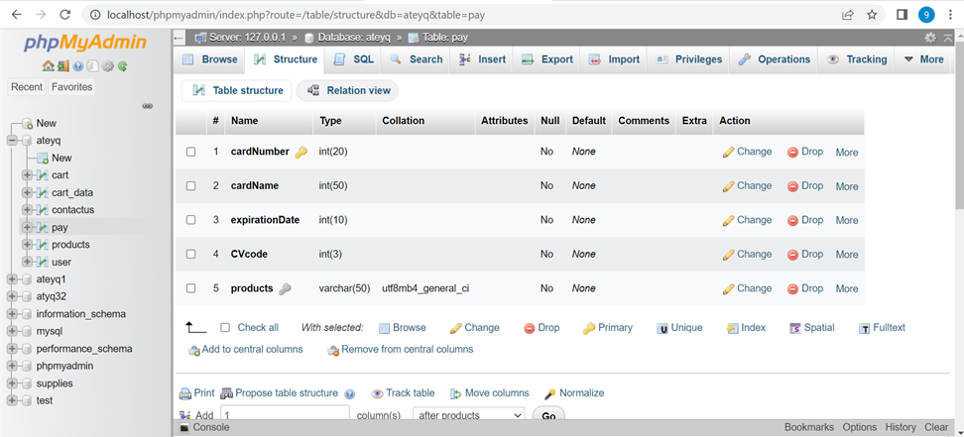

Figure Pay table

## 6.3 Contact us table:

Stores information about contact id (Primary key), first name , last name , phone , email , message , attachment

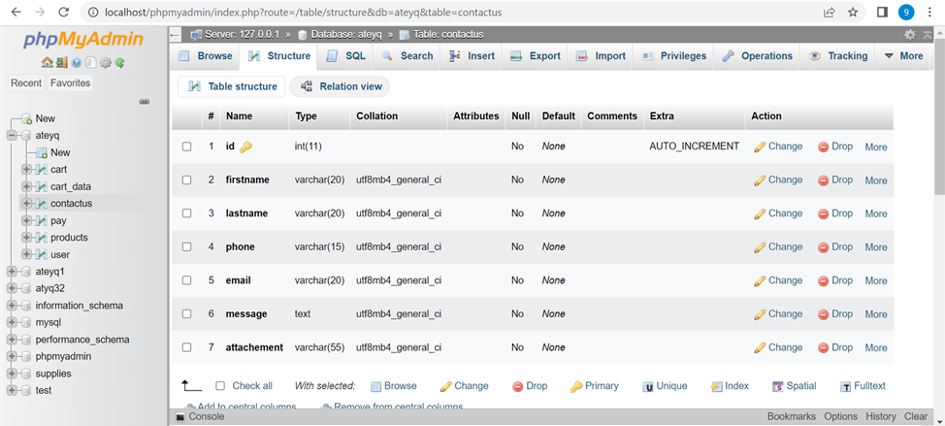

Figure Contact us table

## 6.4 Cart_data table:

Stores information about cart id (Primary key) , product , qty ,amount .

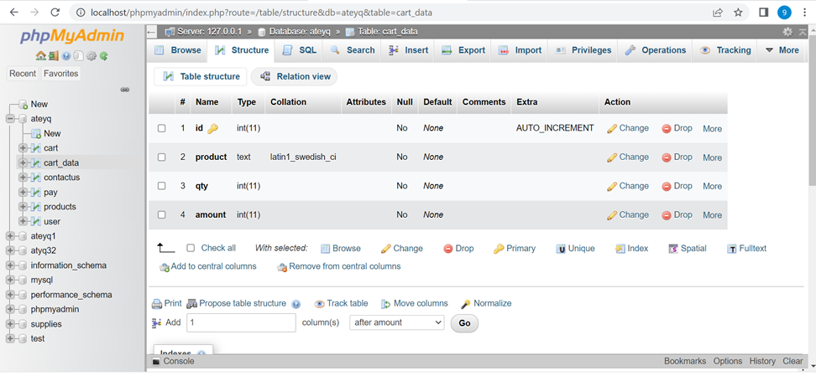

Figure Cart_data table

# 7. Tables

## 7.1 Cart Table

|  |  |  |  |  |  |  |  |  |
| --- | --- | --- | --- | --- | --- | --- | --- | --- |
| Column | Type | Attributes | Null | Default | Extra | Links to | Comments | MIME |
| product | varchar(50) |  | No |  |  |  |  |  |
| quantity | int(100) |  | No |  |  |  |  |  |
| price | int(100) |  | No |  |  | ->product.price  ON UPDATE RESTRICT  ON DELETE RESTRICT |  |  |

Table 1: Cart Table

## 7.2 Products Table

|  |  |  |  |  |  |  |  |  |
| --- | --- | --- | --- | --- | --- | --- | --- | --- |
| Column | Type | Attributes | Null | Default | Extra | Links to | Comments | MIME |
| cups | varchar(11) |  | No |  |  |  |  |  |
| Magazine | varchar(11) |  | No |  |  |  |  |  |
| HandMade | varchar(11) |  | No |  |  |  |  |  |
| Tea | varchar(11) |  | No |  |  |  |  |  |
| price | int(50) |  | No |  |  |  |  |  |

Table 3: Product Table

## 7.3 Sign in Table

|  |  |  |  |  |  |  |  |  |
| --- | --- | --- | --- | --- | --- | --- | --- | --- |
| Column | Type | Attributes | Null | Default | Extra | Links to | Comments | MIME |
| Email | varchar(50) |  | No |  |  | ->signup.Email  ON UPDATE RESTRICT  ON DELETE RESTRICT |  |  |
| password | int(11) |  | No |  |  |  |  |  |

Table 3: Sign in Table

## 7.4 Sign up Table

|  |  |  |  |  |  |  |  |  |
| --- | --- | --- | --- | --- | --- | --- | --- | --- |
| Column | Type | Attributes | Null | Default | Extra | Links to | Comments | MIME |
| Email | varchar(50) |  | No |  |  |  |  |  |
| firstName | varchar(50) |  | No |  |  |  |  |  |
| lastName | varchar(50) |  | No |  |  |  |  |  |
| password | int(50) |  | No |  |  |  |  |  |
| Phone | int(15) |  | No |  |  |  |  |  |
| address | varchar(100) |  | No |  |  |  |  |  |

Table 4: Sign up Table

## 7.5 user Table

|  |  |  |  |  |  |  |  |  |
| --- | --- | --- | --- | --- | --- | --- | --- | --- |
| Column | Type | Attributes | Null | Default | Extra | Links to | Comments | MIME |
| username | varchar(50) |  | No |  |  |  |  |  |
| Email | varchar(50) |  | No |  |  |  |  |  |
| Phone | int(10) |  | No |  |  |  |  |  |
| address | varchar(50) |  | No |  |  |  |  |  |
| password | int(50) |  | No |  |  | ->signin.password  ON UPDATE RESTRICT  ON DELETE RESTRICT |  |  |

Table 5: User Table

# 8. ER Design

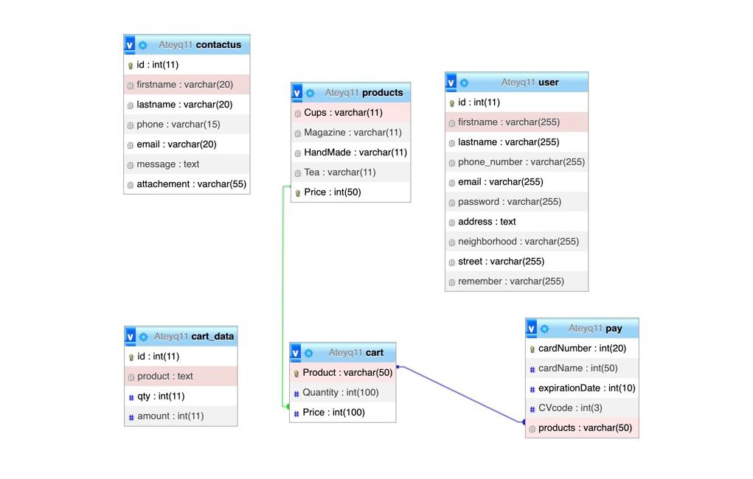

Figure ER Design

# 9. Fulfilled Requirements

- Some of the tasks that work correctly are that when the user click Add to Cart, the product will move to the cart, and when the product is increased, the price will double according to the number of products added, and when it is deleted, the product will be deleted from the cart. When entering wrong data by the user wrong message will appear.

-The tasks that we wanted to develop, but we did not succeed in that, is that when the customer buys from the store, the databases are updated and the quantity decreases. Also the regular method of adding the map into the contact us method did not succeed because we were not able to make a key from the goggle map website . Instead, the iframe tags was used to add the map as an external document.

-Some of the tasks we did not develop it on our site is to enable customers to write their feedback about the products, the ability of the customer to search for products through the search engine, allowing the customer to convert between Arabic and English when he needs and to convert when using the mobile device or computer.

# 10. Testing Case

When the user forgets to complete the field, a warning message will appear and will not be able to move you next page until he completes it.

Figure

If the user fills in the wrong data, the error message will appear.

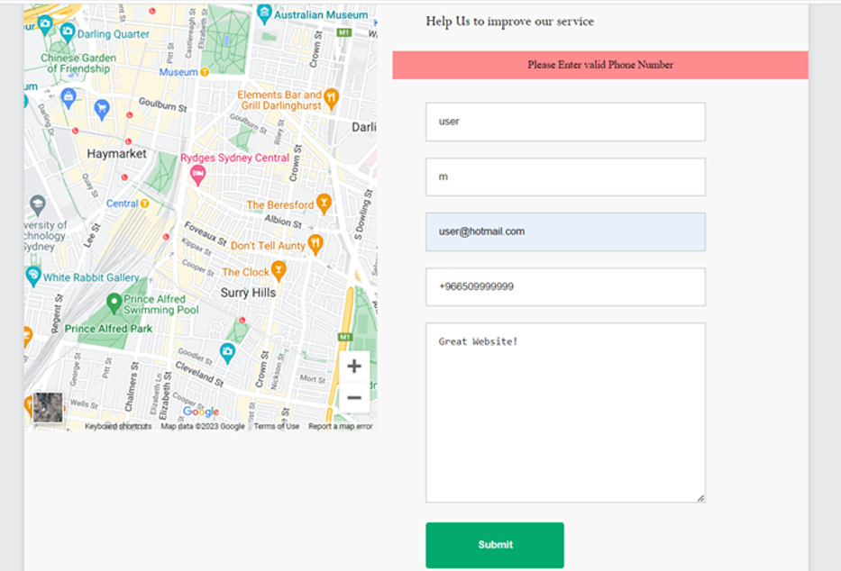

Figure

The format of the email will be checked, so user must enter correct value

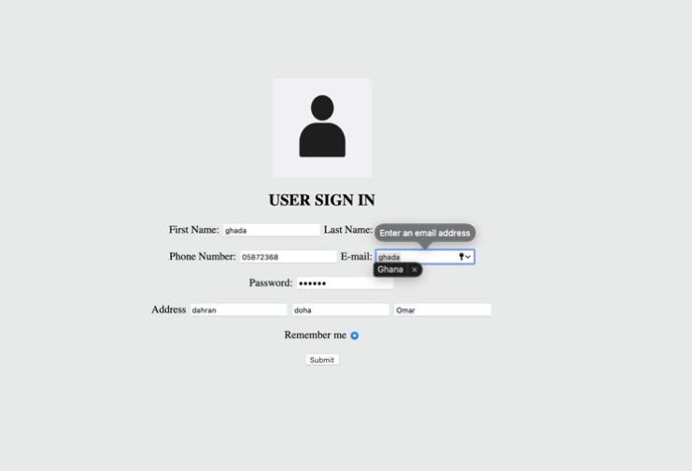

Figure

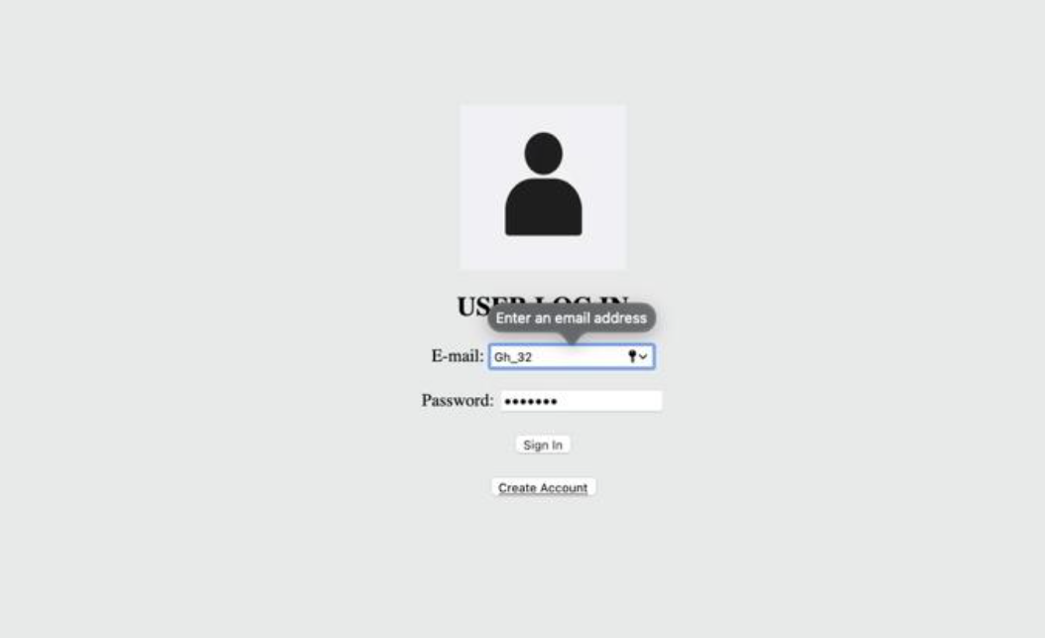

Figure

# 11. Conclusion

Atyeq is a website that offer to users to shop different proudcts in easily way This project aimed to provide website that enable user to deal with in easy way we provide in this report all web pages analysis were performed to illustrate all the functionalities that will be performed via the system.

In conclusion, all the functions of the Atyeq site have been mentioned and covered, as it was programmed using HTML, CSS, PH and JavaScript, and provides flexibility in dealing with products and saving them in the database with flexibility.